Tysoe Wildlife Review – Making Space for Nature

Here is a brief overview of the plans and activities of Tysoe Wildlife over the past 2 years.

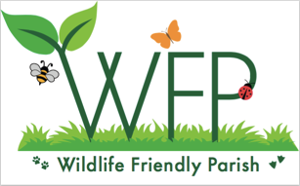
Mission statement
Our aim is to preserve and nurture nature in the Parish of Tysoe for everyone to enjoy, by protecting natural habitats and encouraging greater biodiversity in animals and plants. We hope to turn Tysoe into even more of a Wildlife Friendly Parish.

Designated Wildlife Areas
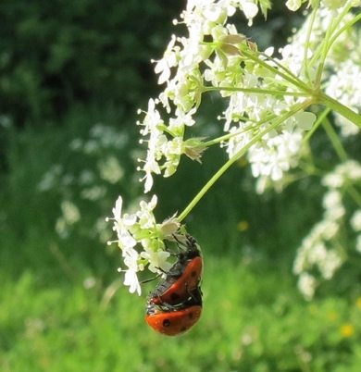
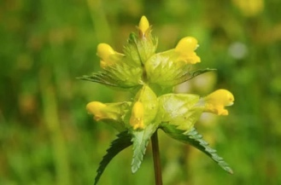
The ‘Making Space for Nature’ initiative started in August 2019 with the dedicated wildlife area in St Mary’s Churchyard. This includes two plots which were sown with yellow rattle and some green hay from the churchyard at Oldberrow Oldberrow: St Mary’s – Caring For God's Acre (caringforgodsacre.org.uk). The Parish Council subsequently agreed that we could develop the large verge in School Lane into a wildflower area. The yellow rattle that was sown in both areas has done very well. In addition to the wildflower areas, bird boxes (constructed by local children from kits made by David Bell) and a hedgehog bunker were installed in the churchyard and a new wildlife hedge was planted in winter 2020-21 with a selection of native species including hawthorn, blackthorn, field maple, hazel, crab apple, wild pear, buckthorn, spindle and guelder rose. The hedge will provide shelter and a source of food for birds and insects once it gets going. The buckthorn was included as it is the foodplant of the caterpillars of the brimstone butterfly. Some patches of nettles were left in summer 2021 for the caterpillars of peacock and small tortoiseshell butterflies.

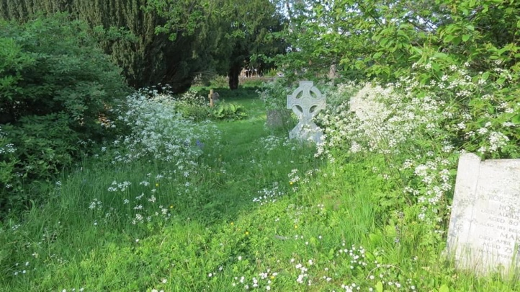
It is important to appreciate that creating wildflower areas is not the work of a moment. It takes time to establish the flowers and suppress the grasses. These areas may not always look pretty in the conventional sense, but the benefits to nature are significant. The wild areas in the churchyard played a key role in the Wildlife Week for local children and the yarrow in School Lane has been particularly spectacular.

Grant from the Caring for the Cotswolds Scheme

In late 2020, with support from the Parish Council, we applied for a match-funded grant from the Cotswolds National Landscape (formerly Cotswolds AONB) ‘Caring for the Cotswolds Scheme’ Caring for the Cotswolds - Cotswolds National Landscape (cotswoldsaonb.org.uk) and were awarded a grant of £1,262. We are very grateful for the grant and the matched-funding provided by Tysoe Parish Council, the Tysoe & District Record, the Upton Estate and the Tysoe Utility Trust plus an individual donor. This grant was to purchase three information boards and to create a nature map of Tysoe as a leaflet.

Facebook and web pages

A new Facebook page was created for Tysoe Wildlife @tysoewildlife which carries regular posts on wildlife and environmental topics. We also linked up with a group of villages who are developing plans for wildlife. This group was initiated by Sophie Flux at the village of Risby in Suffolk Home | Wildlife Friendly Village. They have been happy to share their logo with us – as seen on the Tysoe Wildlife Facebook page and above. There is now a dedicated space on our village website – the address is https://www.tysoe.org.uk/ about_tysoe/tysoe-wildlife/.

Poetry Challenge 2021

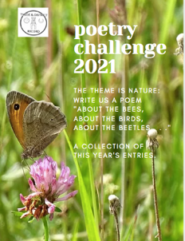
The focus on nature continued with the 2021 Poetry Challenge, run by the Tysoe & District Record. A total of 21 poems were entered into the poetry competition by Tysoe residents. “Every poem inspires us to think, reminding us of nature’s ‘wonder-full’ beauty and, crucially, of how much we really need to respect and care for nature in our lovely Parish of Tysoe and the world beyond.” Emma Restall-Orr, Sun Rising Nature Reserve.

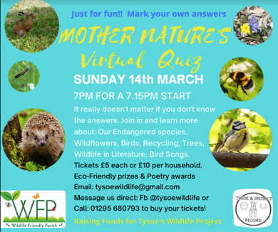
Mother Nature’s Quiz
To raise funds for wildlife we staged a nature quiz. More than 30 households took part in ‘Mother Nature’s Virtual Quiz’ on Mothering Sunday (14th March 2021). It raised over £400 – which was amazing! The funds went towards the project to create information boards and a nature map for the parish, co-sponsored by the Cotswolds National Landscape (formerly Cotswolds AONB).
No Mow May
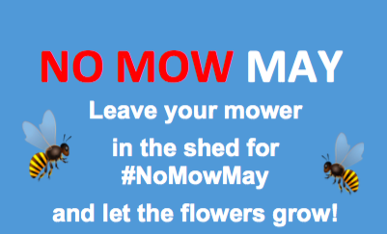
Tysoe was one of many parishes/councils taking part in this important initiative. With the support of the Parish Council, many of our verges, with the exception of those in the centre of the village, took part in ‘No Mow May’. Unmown strips were left beneath the two long hedgerows in the playing fields, to provide more room for wildflowers and insects.

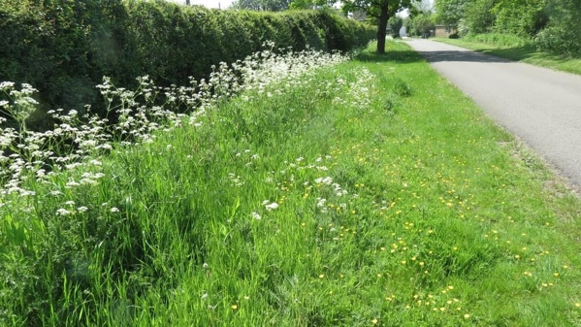
The main flowers seen on the verges in the village were daisies, buttercups and dandelions. They are vital early spring nectar sources for a wide range of insects and many nesting birds depend on insects as a food source. Many residents expressed their delight at seeing the wildflowers growing and there were reports of more butterflies over the summer months.

Additional wildflower areas were marked and prepared in Baldwin’s Lane, Saddledon Street (strip behind the daffodils), the path between Saddledon Street and Back Lane, School Lane and Badger’s Lane. Most of these were sown with mixtures of wildflower seeds, albeit later than originally planned.

Information Boards and Nature Map
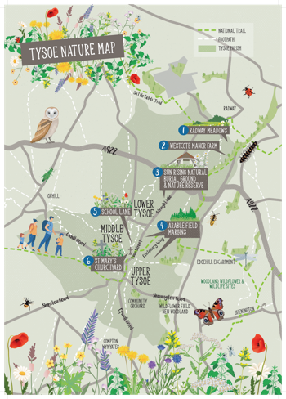
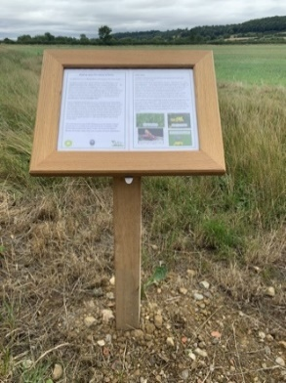
Three information boards have been purchased by the Parish Council and Tysoe Wildlife with the funds provided by the Cotswolds National Landscape (formerly Cotswolds AONB) and local partners. They were installed by the Upton Estate team. The information in them is being updated regularly to reflect seasonal changes.
The nature map has been put together (map, photos, text), laid out by the designer, and printed. The map was distributed to every household in the parish and available to visitors in the Post Office and St Mary’s Church.
Walks and talks 2021
Tysoe Wildlife organised two informal walks, one around the wildlife areas in the village (22nd July 2021) and one through Radway Meadows to Westcote in the company of David Freke (local archaeologist/historian) (17th August 2021).
Twenty-four of us joined the second walk of the meadows between King John’s Lane and Westcote. It was a great mixture of wildlife and history, the historical highlight being the deserted medieval village of Westcote and David’s amazing plan of its layout. Radway Meadows had been mown but we were able to see a mass of yellow rattle seed heads in the adjacent field belonging to David. Some of the seed had very recently been harvested for the Glorious Cotswold Grasslands - Cotswolds National Landscape (cotswoldsaonb.org.uk) project.
We have given talks about our project to the congregation of St Mary’s Church, at a meeting of the Shipston Deanery Eco-Group, at a wildlife day in Great Bourton and at a virtual meeting of the network of villages run by Risby in Suffolk.
Tysoe Wildlife Activity Week – 2-6 August 2021
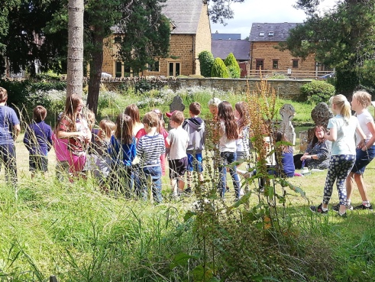
The Wildlife Week was attended by thirty primary school children. It was organised by Tysoe Wildlife, led by Rosemary Collier and Shirley Cherry, with Nicki Campbell (a former teacher) as the principle coordinator, plus a team of helpers and supported by St Mary’s Church. The children engaged in a full programme of activities at St Mary’s Church, combining science education, crafts and games based on a different theme each morning. The week was very well received with some excellent feedback which made it all worthwhile e.g. “Everly has thoroughly enjoyed all of the activities, made new friends and learnt a lot about wildlife.” Jen & Blue (Everly’s mum & dad).
The Activity Week primarily achieved two things:
- It engaged local children in two and a half days of learning activities in and around the church.
- It allowed the children (and adults) to learn more about wildlife and the importance of protecting our natural environment.

Activities in Autumn 2021

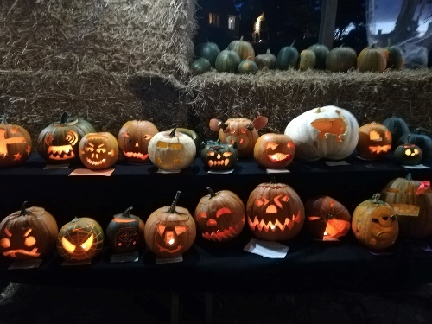
We held a pumpkin carving competition in the parish using pumpkins grown and donated by a local farming business (Happy Herefords). Donations for the pumpkins (£50) and an amazing donation of £500 from a resident of Tysoe will go towards matched funding for a second application that we have submitted to the ‘Caring for the Cotswolds’ scheme.

Activities in 2022

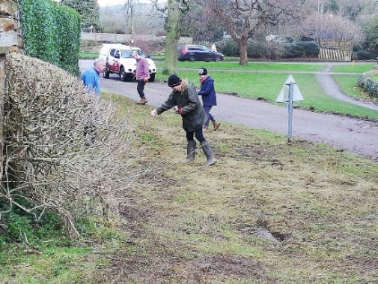
The Warwickshire Wildlife Trust offered to help Tysoe Wildlife sow wildflowers in School Lane and in strips along the edges of the playing field. This is part of their Wilder Communities project funded by Severn Trent Wilder Communities | Warwickshire Wildlife Trust. The seeds were sown by the Wildlife Trust and a group of volunteers on 16th January 2022. This initiative was supported by Tysoe Parish Council.

We were successful in winning additional funding from the Cotswolds National Landscape Caring for the Cotswolds Scheme, which was matched by a very generous donation from a Tysoe resident. We are very grateful to both donors. The funding was used to support events and activities in 2022.
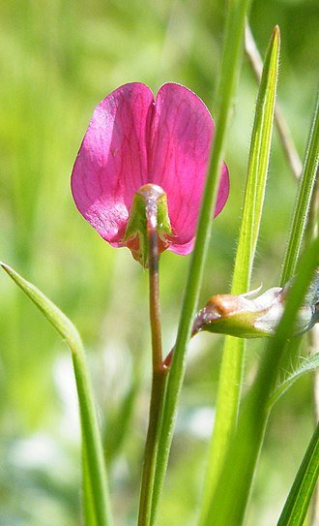
Visits to Sun Rising Natural Burial Ground Nature Reserve
We made monthly evening visits in spring and summer to the Natural Burial Ground (Sun Rising Natural Burial Ground and Nature Reserve) to follow the development of the wildflower areas in particular and to learn more about their management. These visits were hosted by Emma and David Restall-Orr and were much enjoyed. One of the outstanding plants was the Grass Vetchling, sown at the Natural Burial Ground but occurring naturally in the Warwickshire Wildlife Trust nature reserve at Radway Meadows.

No Mow May
With support from the Parish Council, Tysoe again took part in No Mow May and most of the verges within Upper, Middle and Lower Tysoe were not mown during May.

Bat night
Members of the Warwickshire Bat Group led by Tricia Scott held a bat evening in the church and churchyard on 28th May 2022. About 50 people attended, including around a dozen children. The evening started with refreshments, including some excellent lemon and chocolate bat biscuits made my Jane Gardner. Tricia then gave a short talk and answered a good number of questions before we went outside with bat detectors to listen for local bats. Sadly, the weather was cool and breezy, not good for flying insects and so we didn’t hear many bats, although there were pipistrelles and a Myotis bat.
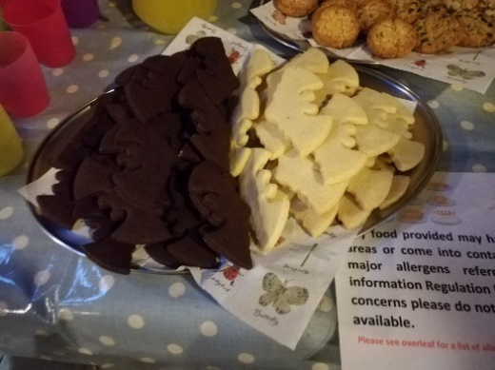
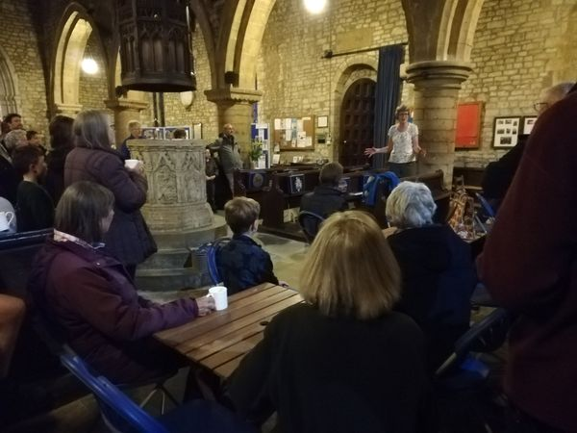

Platinum Jubilee
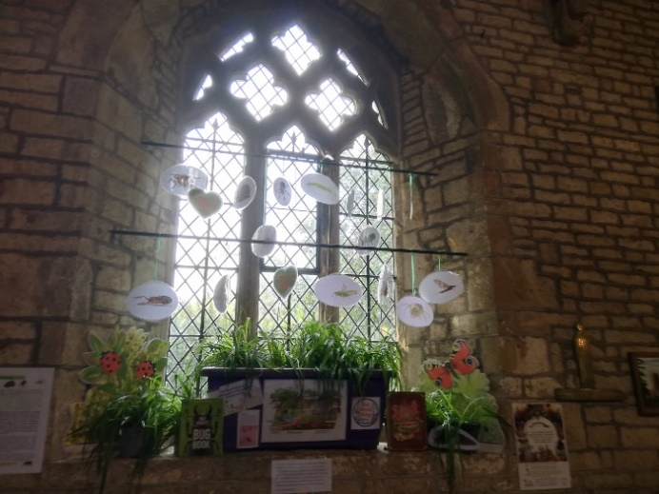
Tysoe Wildlife took part in an open day in St Mary's Church and Churchyard on 3rd June 2022. There was a display, bug hunt, spider and dragonfly craft activities, and storytelling - plus the wildlife areas in the churchyard and School Lane.
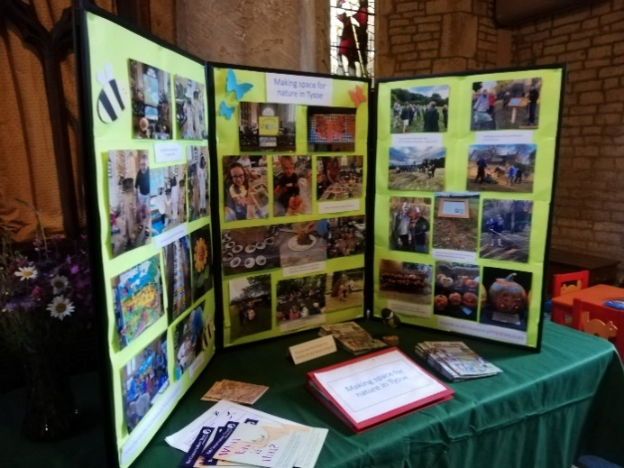

Survey of Radway Meadows
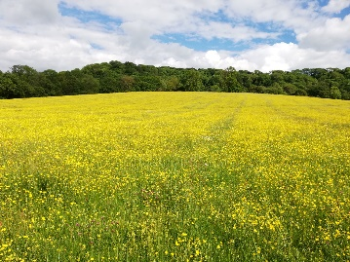
In June 2022 a small group re-enacted a survey of the Warwickshire Wildlife Trust nature reserve at Radway Meadows (neutral unimproved grassland – so probably one of the main local habitats prior to agricultural intensification) and the adjoining privately-owned, but similarly managed, meadows. The original survey was undertaken on 8th June 1996 by the Warwickshire Research in Nature Group (25 recorders). We recorded birds and plants and a few moths but unfortunately the Warwickshire Moth Group could not visit us with their light traps as they were already booked. A moth night with several light traps is planned for 17th June 2023.

Hedgerow pears
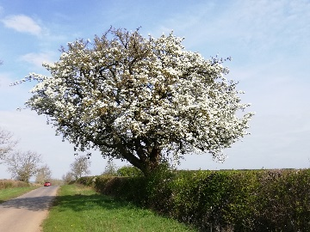
Some of us have been exploring the origins and diversity of the hedgerow pears that are relatively abundant in the area. This year we sent leaf samples to be DNA-typed from 4 trees that are in a row in a field hedgerow in Whatcote to see if they were closely related to one another, as they appear to have been planted. The results need more analysis but suggest that the 4 trees aren’t related and were therefore probably grown from seed. There is an article about the trees here: Have yourself a perry Christmas… — Resonate Festival.

Workshop for young people
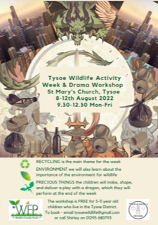
Following the succes of our first workshop in 2021 we held a second Wildlife Workshop in summer 2022 (8-12 August) to engage local children and their families.
The aim of the workshop was to inspire young children with a love and understanding of nature. This year 30 children worked together to produce a play featuring a dragon which they performed on the Friday evening, after only five morning sessions!
Monday - Dragon Day This involved the children finding out their dragon names, reading the play, making dragon pictures and trying to decide how to classify a dragon - reptile or bird?
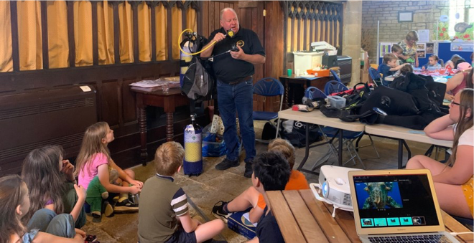
Tuesday - Oceans Day This saw a visit from scuba diver, Nigel Maris. The children tried on some diving kit. We also made jellyfish, crabs, tropical fish and found out about plastics in our oceans.
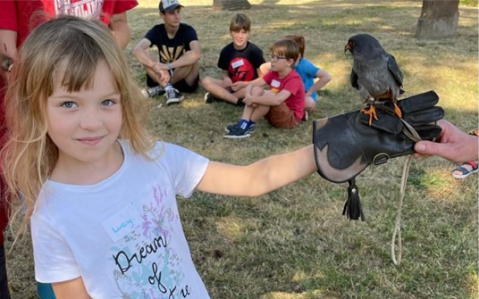
Wednesday was all about Birds - Fir Tree Falconry paid a flying visit. The children met two owls and a red footed falcon and got to hold the latter.
On Thursday we made Props, including a group art Cityscape and rehearsed the play.
Friday - learning about Recycling, making skittles out of plastic bottles for a skittles tournament and our final dress rehearsal.

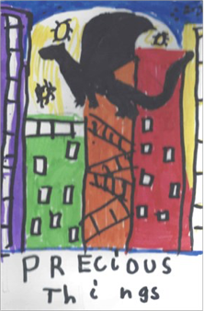
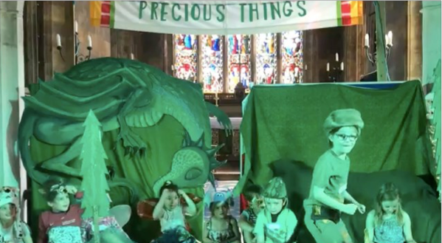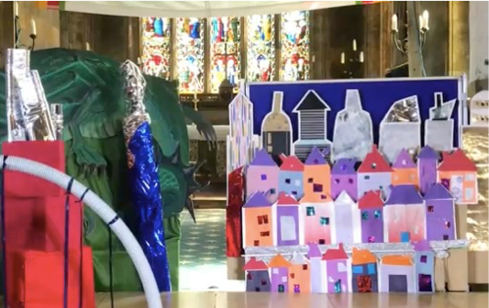

A major part of the time was spent on engaging the children in the development and performance of the play using recycled materials.

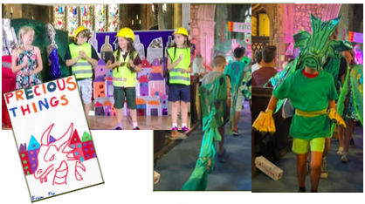
The moral of the play was that humans and nature should live in harmony with one another and how we should respect and care for our planet, not simply exploit it for our own ends.

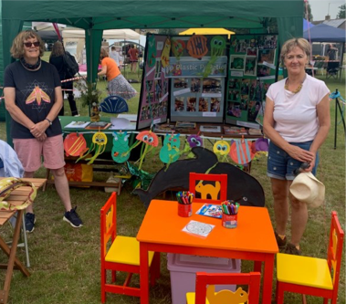
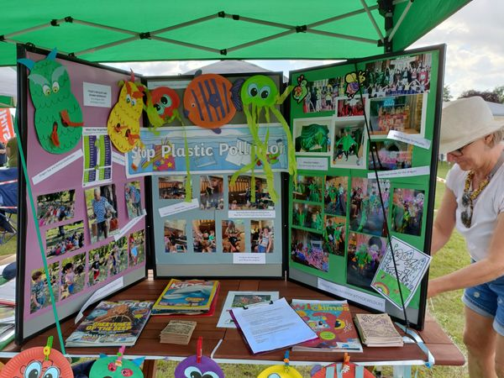
Tysoe Flower Show
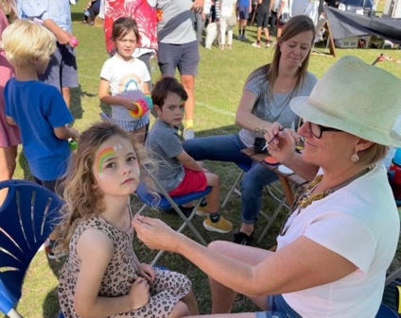

Tysoe Wildlife had a stall at Tysoe Flower Show. There was face painting and a butterfly quiz – with prizes (bird feeders). We also displayed images of the recent workshop.

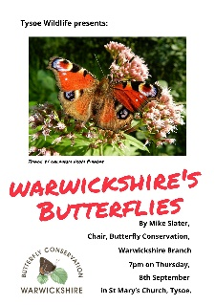
Butterfly talk
Mike Slater, the Chair of the Warwickshire Branch of Butterfly Conservation, gave an excellent talk on Warwickshire’s butterflies in St Mary’s Church on 8th September 2022. Very sadly this was the day that the Queen died. We decided to continue with the talk as the news arrived quite late, but before the talk Jennie Rake led us in a short prayer for the Queen. About 20 people attended and there were many questions.

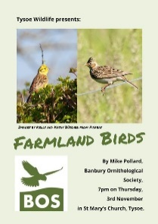
Farmland bird talk
On 3rd November 2022, more than 50 people attended a talk in St Mary’s Church by Mike Pollard, Conservation officer, Banbury Ornithological Society. Mike’s talk related particularly to the birds we see in the area. Again, there were many questions from the audience.
South Warwickshire Area Network for Wildlife (SWAN)
During the year a number of villages in south Warwickshire, plus Shipston-on Stour, have formed a network of wildlife friendly communities. We currently meet every 2 months and this has been a great forum for exchanging information about events and activities. The aims of the SWAN for Wildlife network are to:
- Be an umbrella organisation, networking grass-roots wildlife groups in the South Warwickshire area, sharing information, knowledge, resources, skills and provide a link to national organisations.
- Raise awareness of local nature and wildlife, inspiring people to make space for nature within their communities and encouraging them to value and protect it.
- Support wildlife projects within members’ groups, and the wider area of South Warwickshire.
- Support and link with conservation-based groups and identify environmental issues and campaign for them.
- Organise events to help to spread the wildlife message and to raise funds to support the operations of the SWAN network.
This is potentially an important time for biodiversity in the UK as the new Local Nature Recovery Strategy is due to start. This focuses on supporting biodiversity at the landscape scale and so SWAN is very pertinent.
Activities in 2023
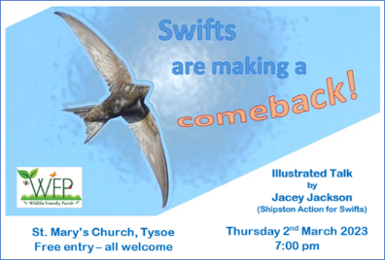
Talk on swifts
Jacey Jackson from Shipston-on-Stour gave a talk about swifts in St Mary’s Church on 2nd March, describing their life cycle, behaviour and approaches being taken to assist them locally. Over 20 people attended.

No Mow May
With support from the Parish Council, Tysoe again took part in ‘No Mow May’ and most of the verges within Upper, Middle and Lower Tysoe were not mown during May. ‘No Mow May’ also included the wildlife area in St Mary’s Churchyard.

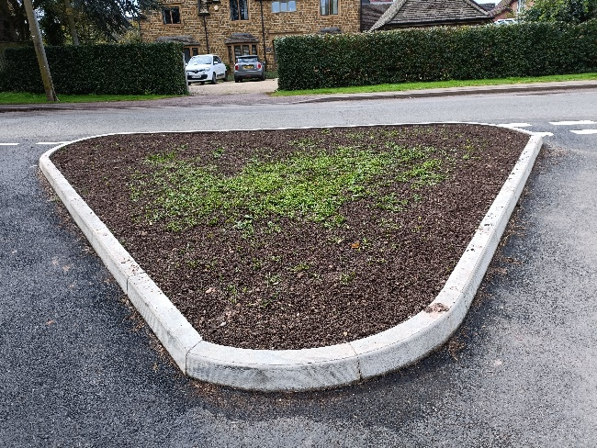
Wildflower areas
There are now wildflower areas in St Mary’s Churchyard, School Lane, along the margins of the playing fields, and a new area at the junction of Sandpits Road and Oxhill Road. A few residents have also developed their own wildflower areas. Yellow rattle seeds collected from the churchyard and School Lane were distributed along the margins of the playing fields to help suppress the grass, and at the time of writing they were doing well. The diversity of species in the wildflower areas is increasing over time and we now have cowslips, wild daffodils, wild carrot, red campion, knapweed and lady’s smock, to name but a few.

The Island
The Island is the small piece of woodland on the right-hand side of the Shipston Road leaving Upper Tysoe. It belongs to members of the Whitney family. Their grandmother, Violet Monk, worked out that Tysoe was equidistant between her two daughters’ families (Solihull and Oxford) and in 1960 she bought a cottage on the junction where Epwell Road, Main Street and Shipston Road meet. She called the cottage "Halfway" – which is its name to this day. The Whitney family (Solihull) liked Tysoe so much that they bought Stone House in Baldwin's Lane in 1963 by auction in the Peacock. The Island was purchased later. The two younger girls attended Tysoe primary school and the two boys had summer jobs on local farms. The family left Tysoe in 1973, but they all have very happy memories.

The family used the Island to grow vegetables and planted the trees, which are now over 40 years old. They have maintained the site during this period with occasional family working parties, most recently in late March. For some years the Island was listed as a Warwickshire Wildlife Trust Nature Reserve and was managed by the Trust but has now been de-listed due to its small size. The family wish to continue to maintain the site for wildlife, and as an amenity for Tysoe, and have asked Tysoe Wildlife to collaborate with them in looking after it.
The Island is mainly deciduous woodland, including large mature oaks and ash, with some areas of grass and scrub. Cowslips were flowering at the time of writing. It’s divided by a small stream, which can flow quite fast at times. As woodland, it’s a great asset to local biodiversity and we will be taking advice from local experts, such as Mike Slater from Warwickshire Butterfly Conservation.

Future events
Moth night 17th June - join the Warwickshire moth group as they discover what lives at this nature reserve managed by the Warwickshire Wildlife Trust. Part of an ancient landscape with 400 year old hedgerows and ancient meadows, it lies below the wooded slope of Edge Hill.

Workshop and Activity Week – 7-11 August 9.30-12.30 Mon-Fri in St Mary’s Church.This summer we will be finding our all about FOOD, FARMING and the ENVIRONMENT. We will be addressing questions such as:
- Where does our food come from?
- What sort of farming happens in Tysoe?
- How important is soil?
- Why do farmers talk about the weather?
- How do farmers decide what to plant?
- What effect does farming have on wildlife and the environment?
We will be working closely with local farmers in and around Tysoe. The workshop is FREE for 5-11 year old children who live in the Tysoe District. To register your interest: email tysoewildlife@gmail.com or call 01295 680793
Summary
As a result of the activities listed above, and regular reports in the Tysoe & District Record, there is now an increased awareness about the importance of wildlife and nature in the parish of Tysoe. More and more people are coming forward to offer their help and support for the initiatives.

We would like to thank Tysoe Parish Council, St Mary’s Church, the Cotswolds National Landscape (AONB) and a large number of individuals for their support.

Prepared by Rosemary Collier & Shirley Cherry
May 2023

