J W Woolliscroft
Carriers Cottage
Copston Magna
Wolvey
Hinckley
LE10 3HE

Tysoe Parish Council Internal Audit
24th May 2023

Additional comments to the Annual Audit Report

The Clerk presented a high standard of record keeping, and the understanding of the policies and procedures required, was good, and all the documents required were easily available.

The following points need to be investigated and addressed.

- It was noted that following a random check of ledger entries, the entries were well recorded and easily navigated. However, a few of issues arose.
In one instance regarding a payment for toilet hire, ref P15, the name on the ledger and the name on the invoice did not concur. This requires amending.
A payment for Clerk’s expenses, P 102, was checked and no invoice or record of the items claimed was found, thus no check of the validity of the claim could be made.
Regarding a payment for repairs to the playground, ref P94, no record or minute authorising the expenditure was found.

- No evidence of the tendering/quotation process was available as this had not been require during this year. However, evidence was available that this process had been followed when required in other years.

- No equal opportunities policy is in place, but I gather a policy is due to be introduced in June 2023.

- The transparency code needs reviewing.

- The Clerk is not fully trained to enable “General Power of Competence”. This should be encouraged and would be beneficial to the Council.

- A formal inspection of the playground equipment by ROSPA was minuted, but the monthly inspections by councillors were not formally recorded and minuted. These should be recorded as part of the due diligence required of the Council in case of any injuries requiring investigation.

- No Disaster recovery/business recovery plan was in place.

- No records were available for the inspections of Council assets.

The Clerk presented a well kept and methodical set of records and was aware of how the systems could be improved. The acceptance of the minor points raised will ensure the Council records and minutes will be improved.

Yours sincerely

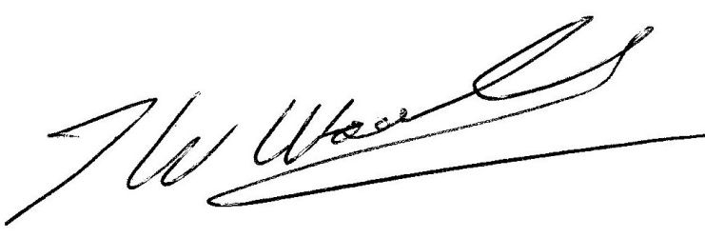

Bill Woolliscroft

