Planning Committee Report – October 2022
Application Number | Address | Details | Consultation expiry
22/02724/FUL & LBC | Winchcombe Farm  Shenington Road Upper Tysoe Warwick CV35 0TH | Replace 20 year old slates with solar slates on south elevation of grade-2 listed barn. | 25/10/2022
GB SOL is the Welsh supplier of simulated Welsh Slate PV tiles which are surface mounted blending into the existing line of Welsh Slate roof. Sample available.
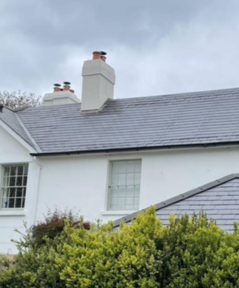
This increases the sustainability of energy and is in line with both Tysoe made NDP Policy 3 and Stratford DC Core Strategy CS.2

Recommend support?

Make no representation. |  | Object |  | Date Decision made
Support the application. |  | No Objection |  | Who will represent the PC at committee?

Previous Applications
Application Number | Address |  |  |  |  | Details |  | Consultation expiry
22/02312/FUL | The Old Posting House, Main Street, Tysoe |  |  |  |  | Erection of a timber framed garage structure from a purchased kit. Timber cladding to the sides and rear with a slate roof to match existing property. |  | 07/09/22
This development is already under construction. The concrete pad is layed and the first uprights are in position.
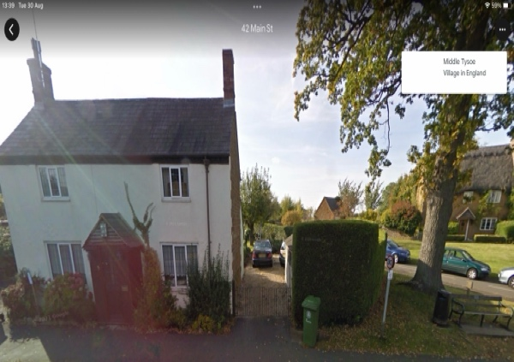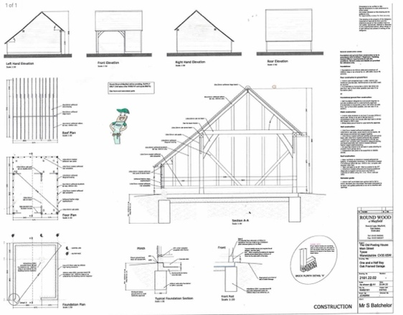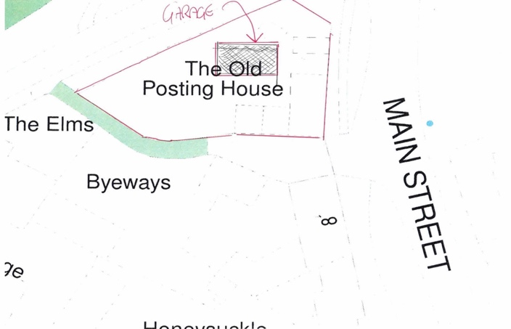
The recommendation would be Make no objection but make the following comments: Any existing trees and hedges must be retained.

Make no representation. |  |  | Object |  | Date Decision made |  | None
Support the application. |  |  | No Objection |  | Who will represent the PC at committee?

Application Number | Address |  |  |  |  | Details |  | Consultation expiry
22/02538/FUL | Greenacres Farm Badgers Lane Lower Tysoe Warwick CV35 0BY |  |  |  |  | Replacement of entrance door and replacement of some of the existing windows with triple glazed windows. The addition of a new window on the north west elevation and closing up of the existing porch windows, and a proposed new opening to the north west elevation |  | 26/09/22
This application is to carry out thermal upgade works to the existing walls, timber casement windows and to install tripe glaze windows. The applicant is also proposing the relocation of the rear entrace and the bricking up (with natural stone) of the existing porch.
Looking at the proposal we cannot see that the changes would make a significant difference to the ‘feel’ of the building and its appearance from the road.

The significant upgrade of insulation and reduce energy consumption of the property should be applauded and encouraged in our opinion as it is more environmentally friendly and increases the sustainability of the property.

Recommendation is to support the proposal on the above basis.

· Relevant policies: CS.2 Mitigation and adapting to Climate Change.
· Material Considerations:
· No overshadowing or loss of light to neighbours
· The proposed changes do not overlook neighbouring property or create loss of privacy.
· The scale and size of the development is not altered.
· The proposed design, appearance, materials, and layout are not significantly different to and are in keeping with the existing building.
· There is not any change to the size of the building and therefore the dominance in the locale is unchanged.
· There are no highway and pedestrian safety issues.
· There is no change to traffic generation.
Make no representation. |  |  | Object |  | Date Decision made
Support the application. |  |  | No Objection |  | Who will represent the PC at committee?
Application Number | Address |  |  |  |  | Details |  | Consultation expiry
22/01913/FUL | Fountain Farmhouse, Lane End, Tysoe |  |  |  |  | Erection of a detached two bay garage with office above at Fountain Farm, Lower Tysoe  The target date for this application is 16 weeks. Government planning policy states it should be 8 weeks. |  | 24/08/22
This is a revised application as the planning officer had very similar conconers to the Parish Council.
The amended drawings include the following changes:
- The windows have been removed on North-west elevation instead replaced by a glazed door and external stair creating a less domestic appearance.
- The WC has been moved upstairs to better serve the office space.
- The hallway, internal stair and WC now being redesignated as a dedicated garden store.
- Two additionally Velux rooflights have been added to compensate for light levels with the removal of the windows.
- The overall height has been reduced by 0.687m and GIA reduced by 3.7m2.

The proposed development is much improved although sizable, more in scale with others in Lane End.
Recommendation – Make no representation.

Previous planning applications
22/02211/FUL | Tysoe Manor Shipston Road Upper Tysoe Tysoe Warwickshire CV35 0TR | Erect a new timber garden shed, erect a timber post and rail fence either side of the public right of way, and install a new oil tank to replace the existing being removed. | Granted 22/09/2022  Target date 16/09/22
22/02059/FUL | Church Farmhouse, Main Street, Tysoe | Infill link from existing house to existing garage and new gate access to garden | Permission granted 31/08/2022  Target date 05/09/22
22/02032/FUL | Tysoe Vale Farm | Erection of a steel portal framed agricultural building with solar panels on the southwest roof slop. | Granted 30/09/2022  Target date 01/09/22
22/01806/FUL | Home Farm, Lane End, Lower Tysoe | Residential development of redundant farm buildings, including listed stable, to 3 residential dwellings. | Pending see Agenda Item  Target date 11/08/22
22/01662/FUL | The Glebe Field, King Johns Lane, Rodway | Proposed change of use of stable to a holiday let | No decision  Target date 27/07/22
20/03658/FUL | Land off Sandpits Road, Tysoe | Full planning application for 31 residential dwellings | No decision  Target date 03/03/22

