Revised Financial Regulations – record of recommendations 4 May 2020
Email from Beverley Thorpe, Parish Clerk and RFO
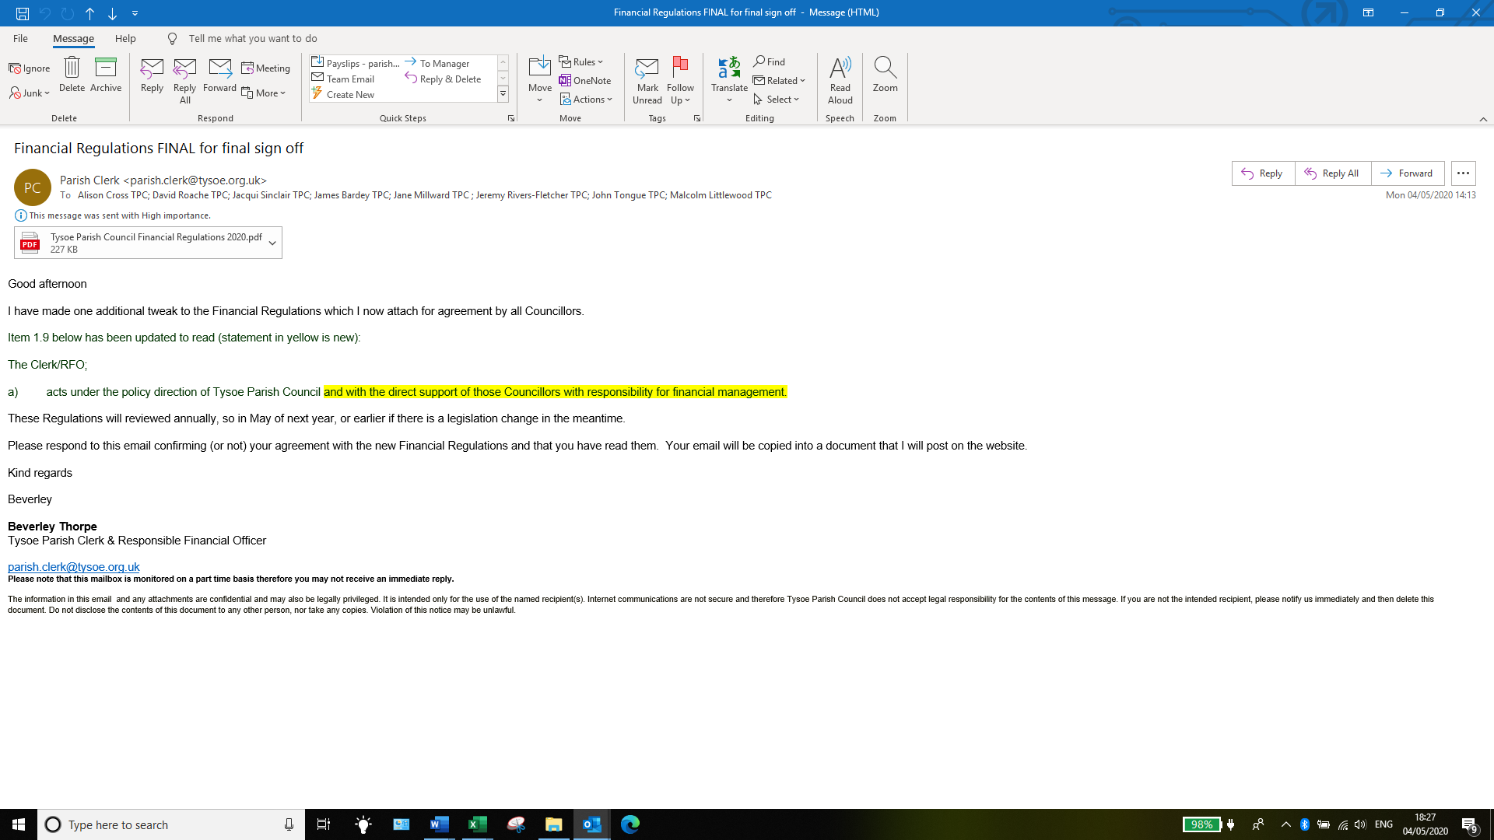
Responses
- Jane Millward
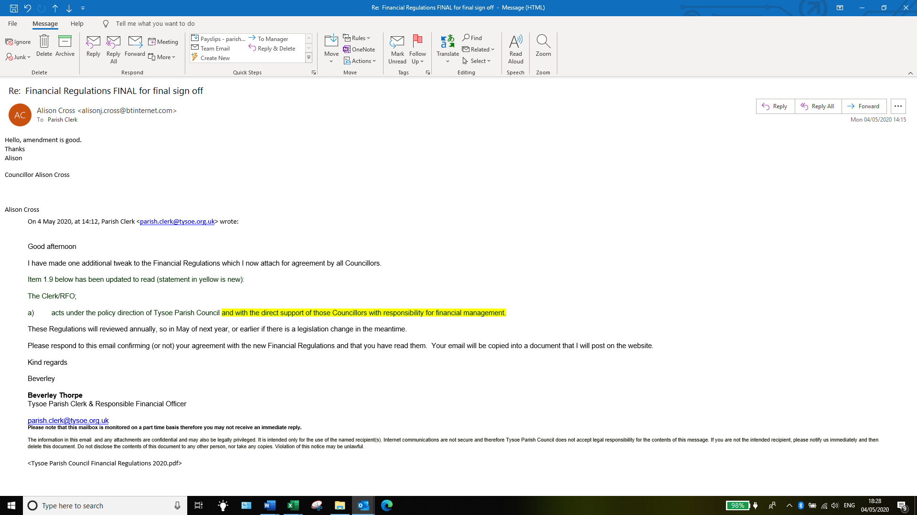

- David Roache
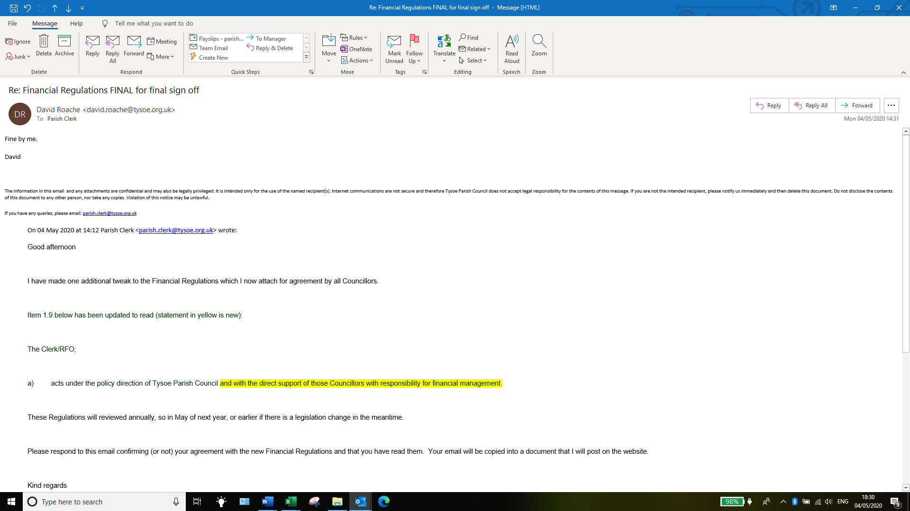
- Alison Cross

- Jacqui Sinclair
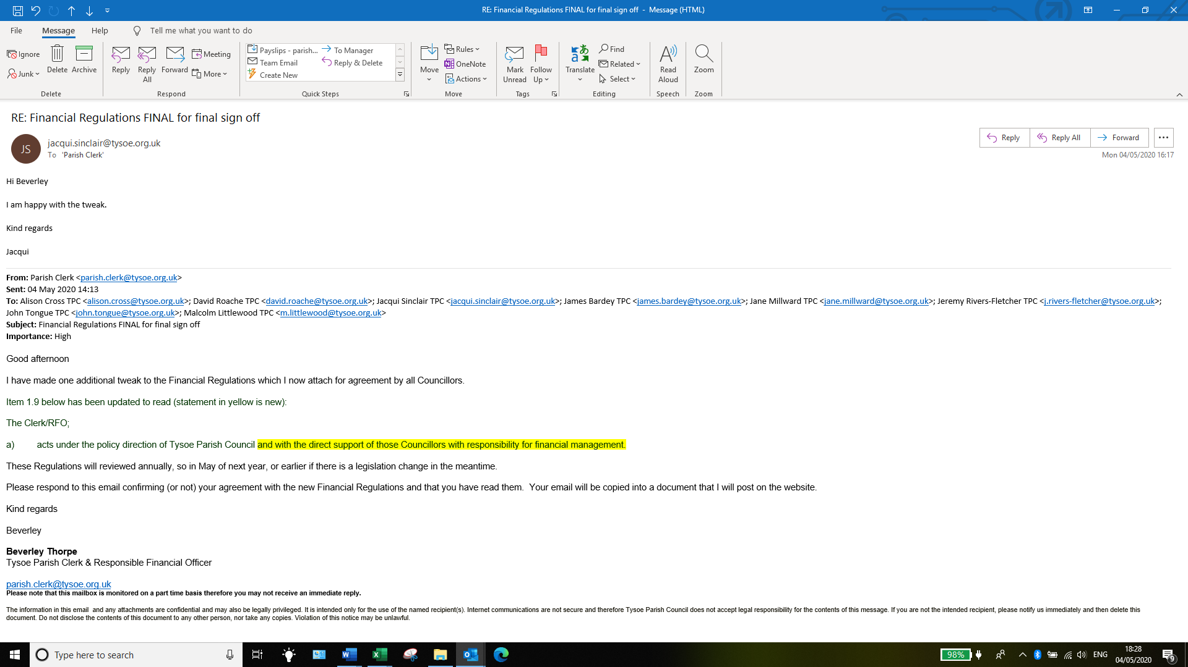
- Malcolm Littlewood
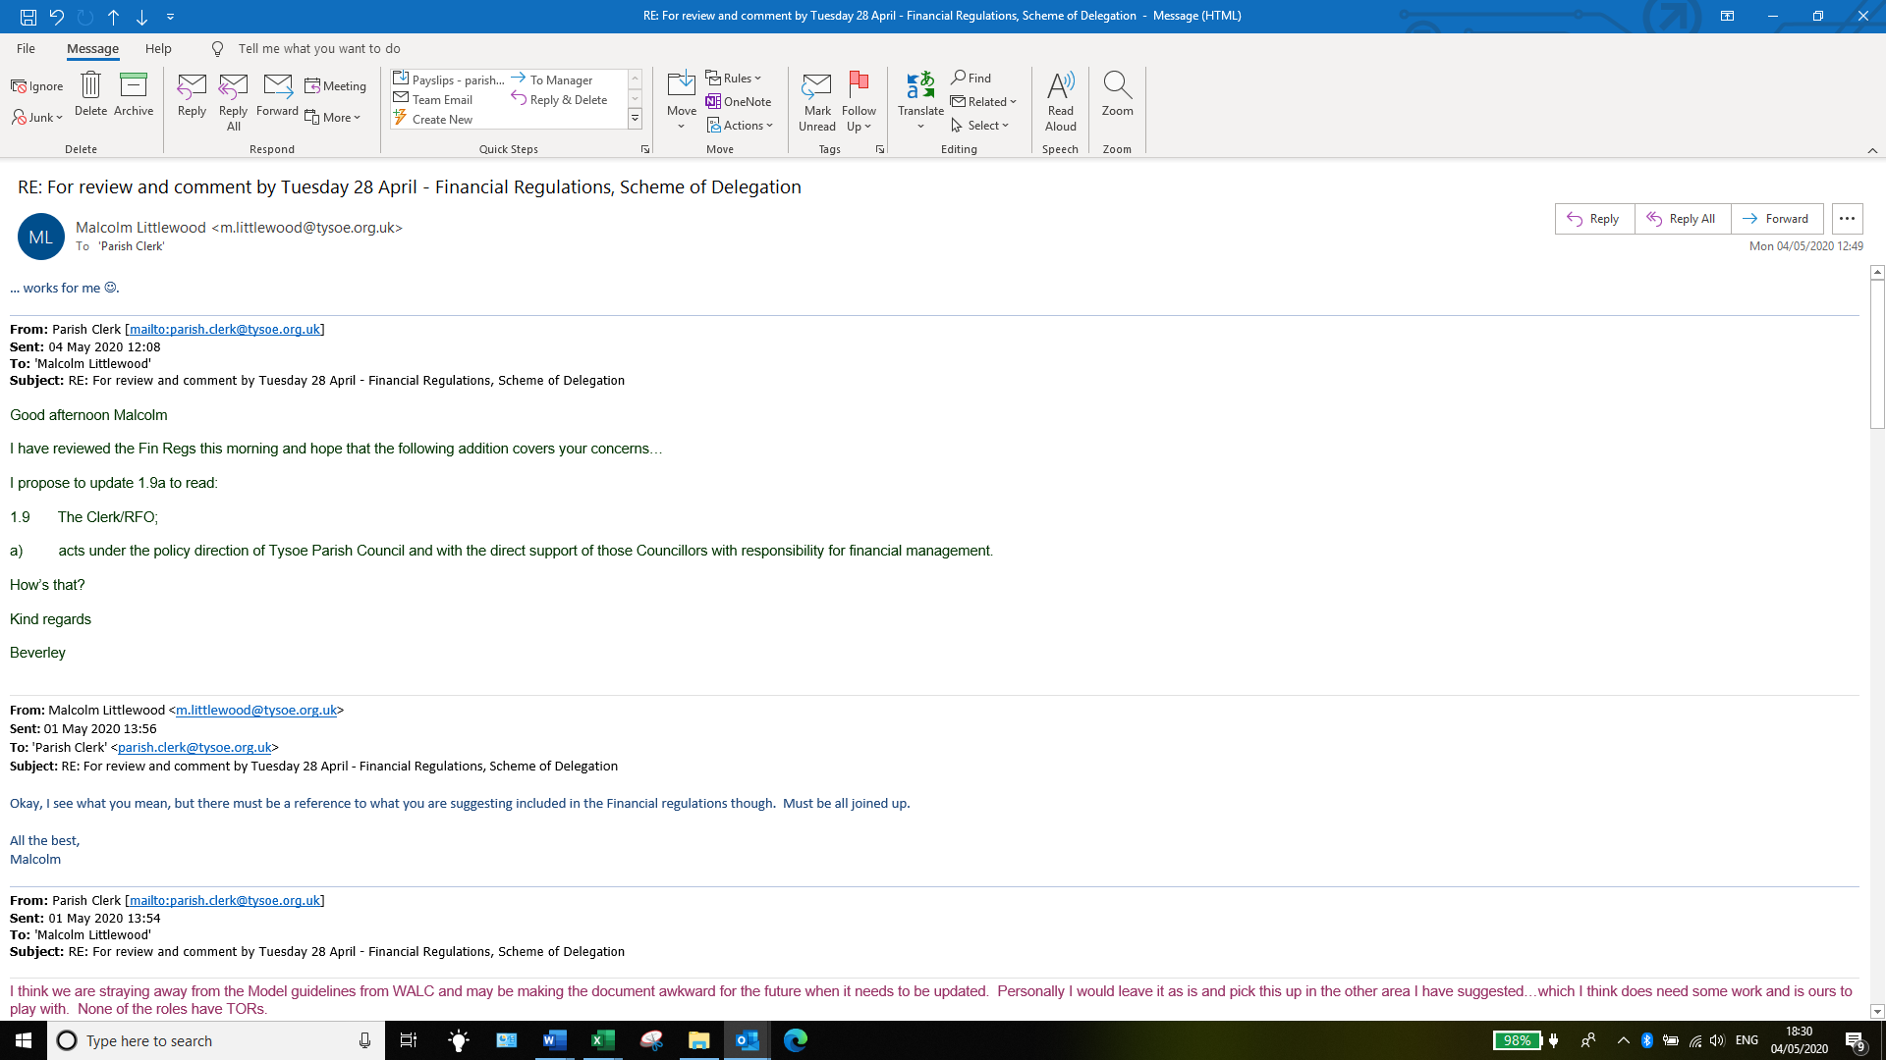

- Jeremy Rivers-Fletcher
