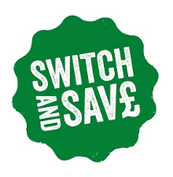

Warwickshire Switch and Save

There has never been a better time for Warwickshire Residents to save money on their gas and electricity bills with Warwickshire County Council's new collective energy switching scheme: Warwickshire Switch and Save.

Following a successful reverse auction between competing gas and electricity providers on the 22nd of May 2018, it has been revealed that residents signed up to the scheme are set to save an average of £177 on their utility bills.

In Warwickshire, about 300 households have registered so far with the scheme and the county’s Switch and Savers have been combined with 37 other similar initiatives from all around the UK to create a consumer collective of over 25,000 registered households.

Residents across Warwickshire have started receiving their personal offer letters or emails letting them know if they will be able to make savings against their current energy deal and, if so, exactly how much money will be going back into their pockets. In total, 75% of people who registered for the scheme in Warwickshire could save on their energy bills if they choose to switch, meaning lots of happy residents in the county.

One Leamington Spa resident contacted Warwickshire County Council to let them know how overjoyed he was when he recently received his personal offer highlighting a £401 saving on his electricity bill!

The message is clear: Don't delay, sign up today to receive your free, no obligation, offer from Warwickshire Switch and Save - https://bigcommunityswitch.ichoosr.com/Product/index.rails?utm_medium=web&location=warwickshire

More information about the scheme can be found here: https://www.warwickshire.gov.uk/switchandsave

