Tysoe Neighbourhood Plan
February 2016 Newsletter
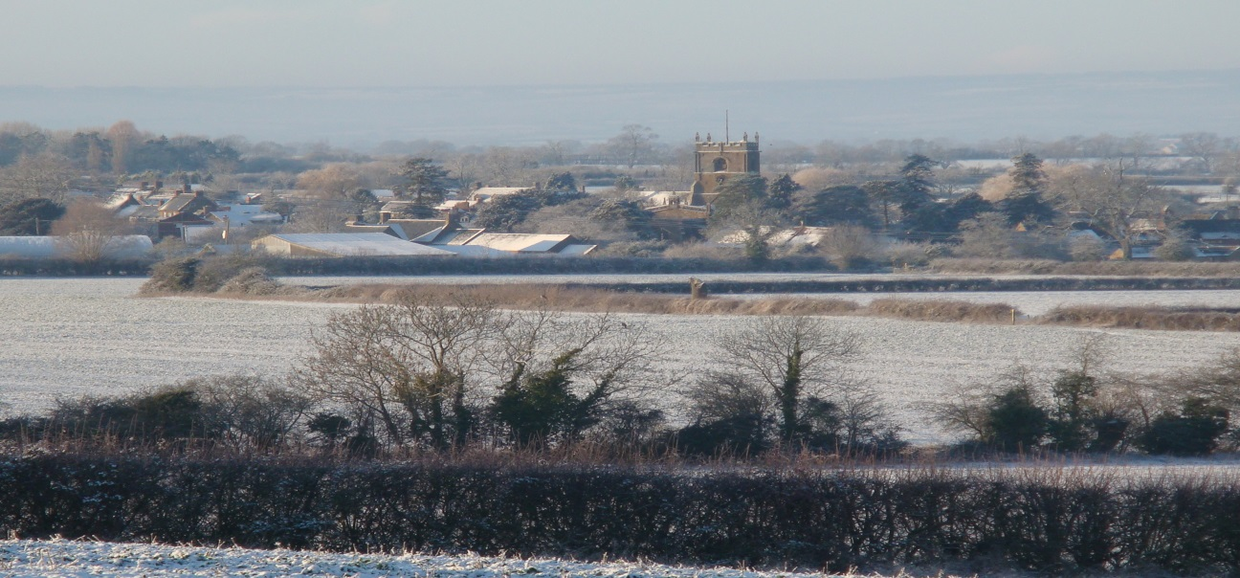
This is the second Newsletter about the Tysoe Neighbourhood Plan (“NP”).
A lot has happened since the last Newsletter was written in September 2015. Much of it was not as expected.
For those who have not been able to follow the developments in Parish Council meetings, we hope this will bring you up to date with the main details, and give you some understanding of what is now planned.
Developments since October 2015
In November 2015 the Steering Committee responsible for guiding the NP since June 2014 decided to resign. They had done a lot of work to get it to its 2nd draft, and thanks have been offered.
This meant that the intention to move forward with a 3rd draft of the NP had to be put on hold. While this has been a set-back, it has also given us the opportunity to reassess the NP: take account of changes in the progress of Stratford District Council’s Local Plan; consider how to involve the community more effectively; and review the most important aims and policies. Changes were needed.
Much of this re-assessment work has been done.
- A new approach to the NP housing policy (‘Site Allocation’) has been recommended by the Parish Council (‘PC’).
- The PC has agreed an interim plan for the progress of the NP until a new steering committee is appointed.
- Advice has been obtained from the planning officers responsible for NP’s at Stratford District Council on how best to proceed with the NP.
- The PC has agreed to form 3 small working groups of residents to help it with the next stages.
There are notes on all this, with useful guides to Neighbourhood Planning, on the Tysoe Parish & Community website www.tysoe.org.uk. . They are available either in the PC Minutes, or on the ‘Neighbourhood Plan’ section.
What’s next?
The PC has circulated a leaflet among all residents seeking volunteers for small working groups to provide short reports on where we are, and what needs to happen next. We have already had a good response to this leaflet, but more volunteers are needed. Please contact a Councillor if you think you could contribute some time.
Residents will be consulted much more over the next few months. It is nearly 2 years since we first started on the NP, and much has changed since then. More houses have been built, and some proposed developments have been refused. There are already changes taking place in the area, and we need to hear the communities’ views.
The NP is not just about new houses. It is also about many aspects of how Tysoe may evolve over the next 15 years or so; and what will help to ensure that this is the kind of community we want for this and future generations. We all have a part to play in this.
To ensure that the NP reflects our aims for Tysoe, it is likely that we will conduct more survey’s, both on housing needs, and on the wider aspects of Tysoe’s development. We hope that the working groups will, among their recommendations, suggest how best to involve us all in this important next stage.
The aim is for the working groups to have been formed, and produced their recommendations, by April. This would enable the Parish Council to report on the next stages, and possibly the formation of a new steering committee, at the Parish Council’s AGM. We hope that as many residents as possible will feel able to attend this.
Making Progress
Despite the unexpected delays to progress, we are far from alone among communities trying to complete their NP’s. Many are finding it more difficult and time consuming than expected. There is only one other community in the District that has completed its NP up to the stage where a referendum of residents is being held.
In the advice* given to neighbourhoods like ours preparing NP’s there is a list of ‘most common mistakes’. The list is shown below. We are not alone in making many of them.
We won’t have to abandon all the work already done. But we can do a lot to build on it, and make sure that it goes well from here on. There are lots of difficult, and many potentially exciting things to consider. There are many people who have already made contributions; and many more who want to contribute.
If we don’t produce a Plan at all, or one that does not reflect what we want, we should not be surprised if the village changes in ways that no-one likes. But rushing it is not the answer. Planning Inspectors, who have to approve NP’s, look very closely at how they have been prepared, and will reject any that do not meet the required standards; for example showing evidence of clear aims and effective consultation.
Making an NP can be divisive of a community. Let’s not allow this to happen. We need to work together as a team, not just going along with the loudest voices.
Please send us your email address; contact us; keep in touch through the website; send us your suggestions; volunteer for the working groups; help with deliveries; complete any survey questionnaires you receive; come along to workshops; invite us to speak at your social events. There are, and will be, many ways to take part.
Will you help? Tysoe needs you.
Tysoe Parish Council
February 2016
Most Common Mistakes
- The ’stand in the library with a thick document’ approach. Not surprisingly few people will read (what appears to be) a completed plan document.
- The ‘talking at people at a public meeting’ approach. Public meetings allow little time for each person to speak, and can often be intimidating and confrontational.
- The ‘consultant producing options before consulting anyone’ approach. It is poor practice to commission consultants to produce options before consulting the local community.
- The ‘publish and defend’ approach. This applies where policies or masterplans are produced first, before consultation has taken place.
- The ‘boring people to the point of unconsciousness’ approach. Public meetings with presentations with dense slides of text are an example.
- The ‘people are too stupid’ approach. The fact that many planning issues are complex is all the more reason why there is a need to involve the wider community.
- The ‘we need strong leadership, not consultation’ approach. Strong leadership is rooted in listening and entering into dialogue. Only weak leaders think they need to instruct, and ignore the opinions of others.
- The ‘outcomes pre-determined’ approach. There is no point in wasting time and money on ‘consultations’ if there is no opportunity to influence what happens.
*Locality ‘Roadmap’ Guide to Neighbourhood Planning

