Tysoe Neighbourhood Plan
Tysoe Needs Your Help
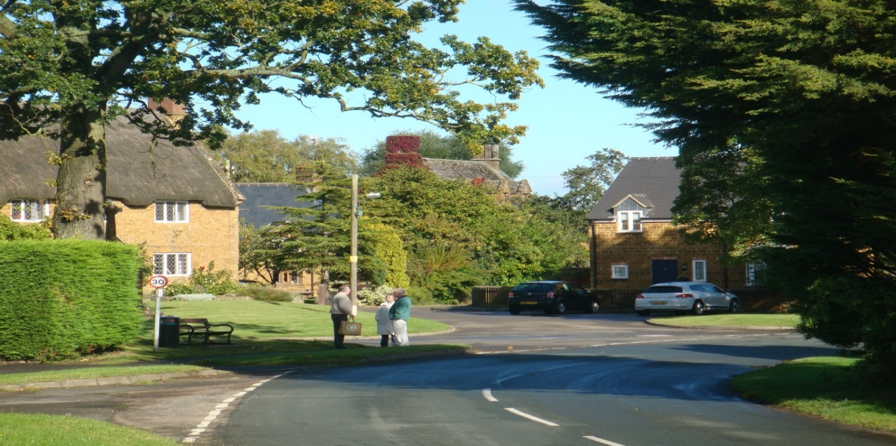
Tysoe Parish Council is intent on getting our Neighbourhood Plan completed.
We are determined to have it done well, with as much involvement of the community as possible. We want to produce a Neighbourhood Plan of which we can all feel proud, and which meets the needs and aims of the Parish of Tysoe.
We need help from the residents of Tysoe to achieve this.
At this stage we need a number of people with a range of skills: for example, marketing, project management, communications, event management, planning, document writing, workshop facilitation, local knowledge and connections.
Most of all we need people with common sense and an interest in the well-being of our community.
Do you have any of these or other skills which you could offer?
You would be asked to be a member of a small working group, taking part in one of a number of projects, over the next 2 to 3 months. We would give you a clear briefing of what will be needed.
The former Steering Group did a lot of work to get us to where we are, but much remains to be done to get the Plan completed.
Please let us know your interest by getting in touch with any Parish Councillor, by phone, email or otherwise.
The following Councillors are responsible for guiding this phase of the Plan’s development:
Keith Risk: Tel: 01295 680 522 Email: keith.risk@tysoe.org.uk
Jacqui Sinclair: 01295 680 592 Email: Jacqui.sinclair@tysoe.org.uk
Further information on the Parish Council and Neighbourhood Plan can be found on the Tysoe Parish & Community Website: www.tysoe.org.uk

